AWS PROJECT

HP | [Company address]

FACE DETECTION APP USING AWS

chaithra chITTI

2020

**Screenshots needed for dashboards**

**AWS login screen with username**

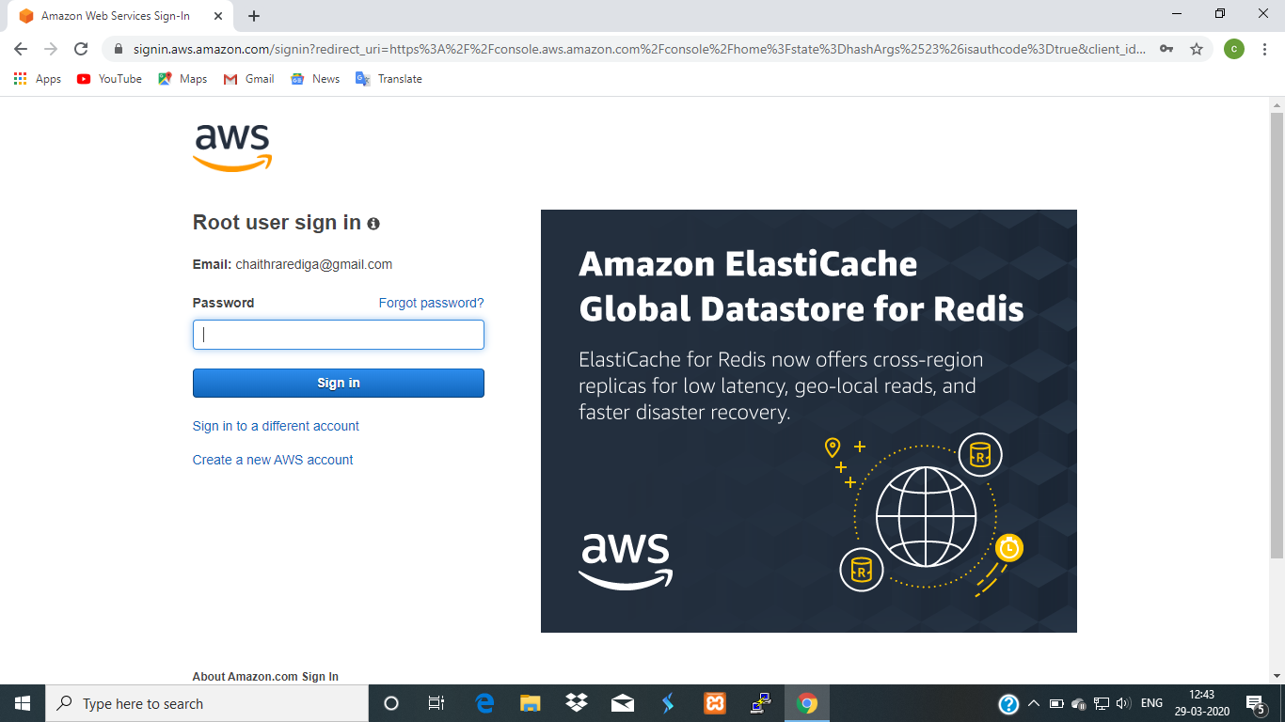

**EC2 dashboard**

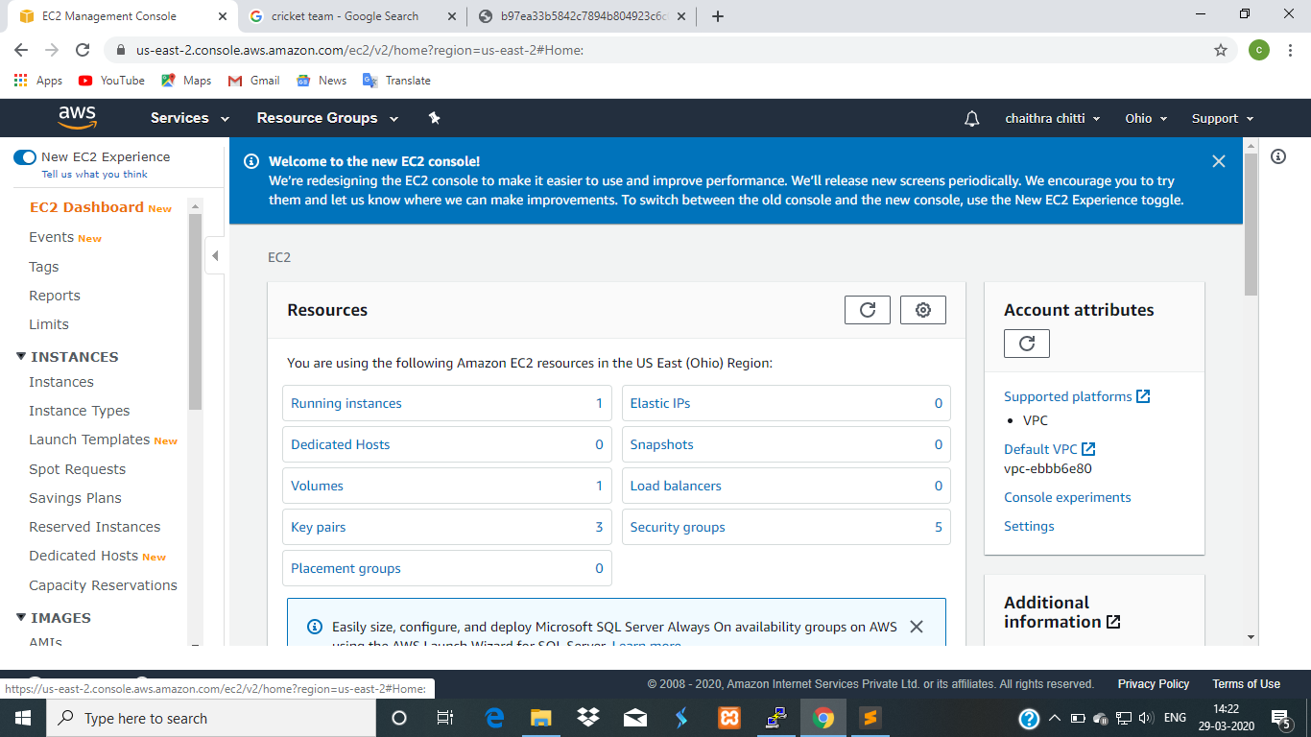

**S3 dashboard**

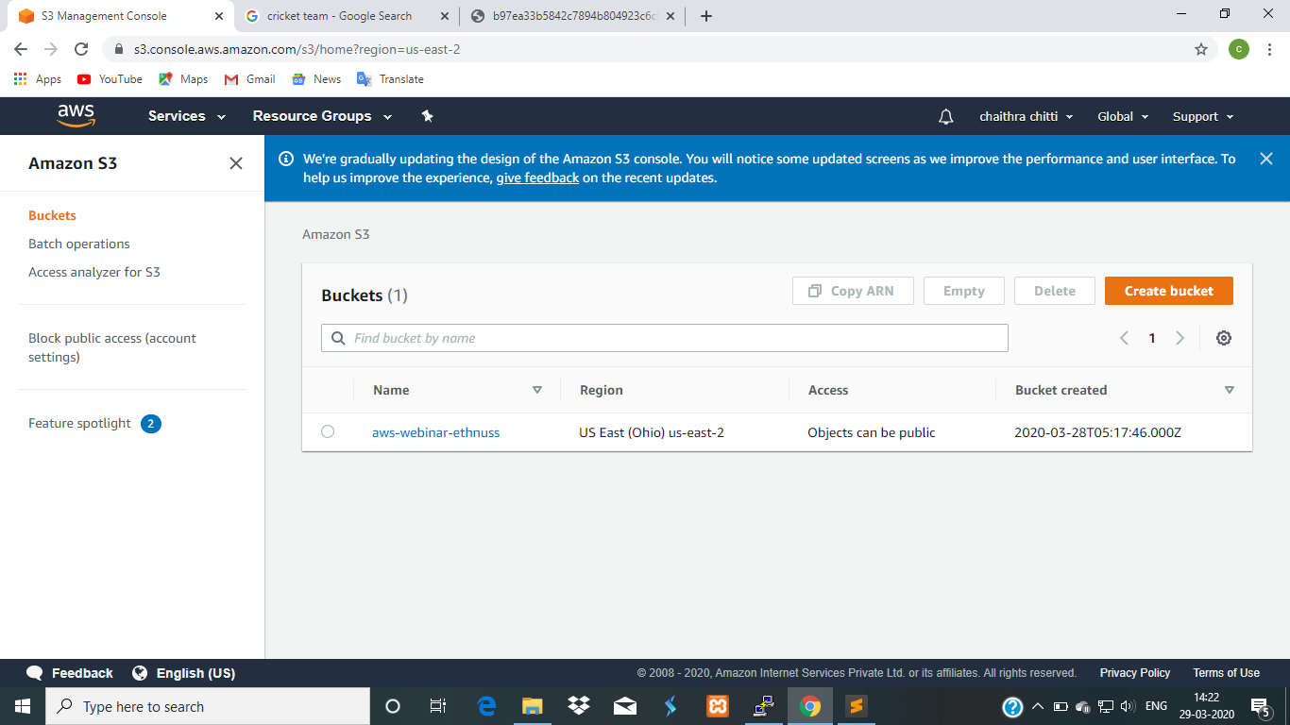

**Rekognition dashboard**

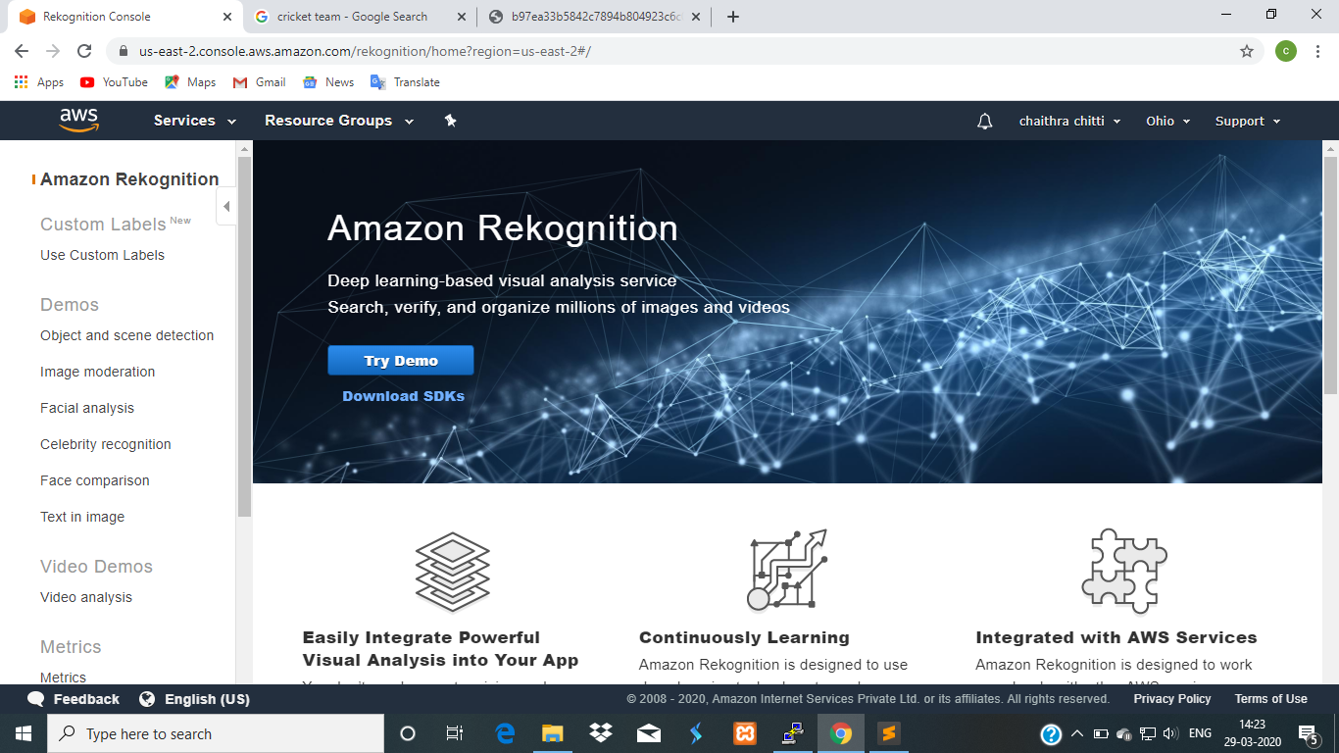

**Screenshots needed for EC2**

**Choosing an AMI**

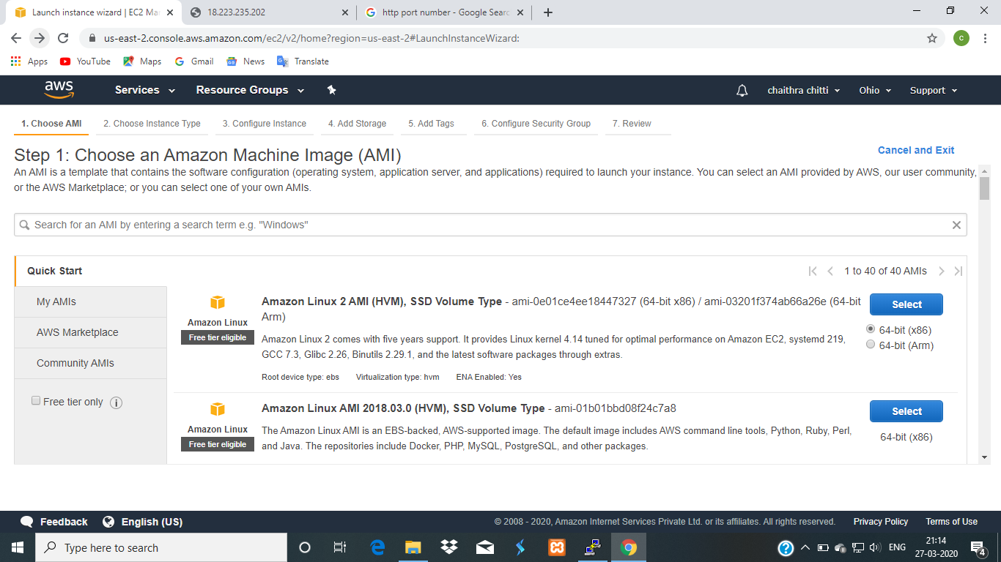

**Choosing an instance type**

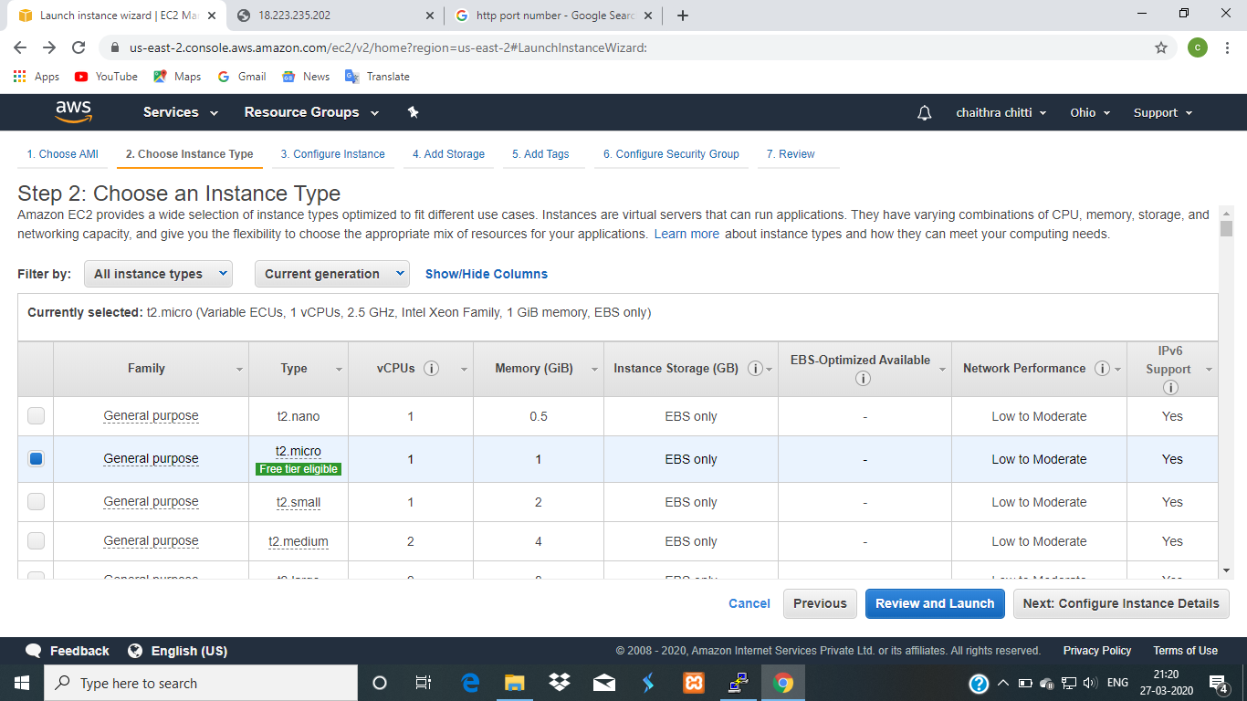

**Adding storage**

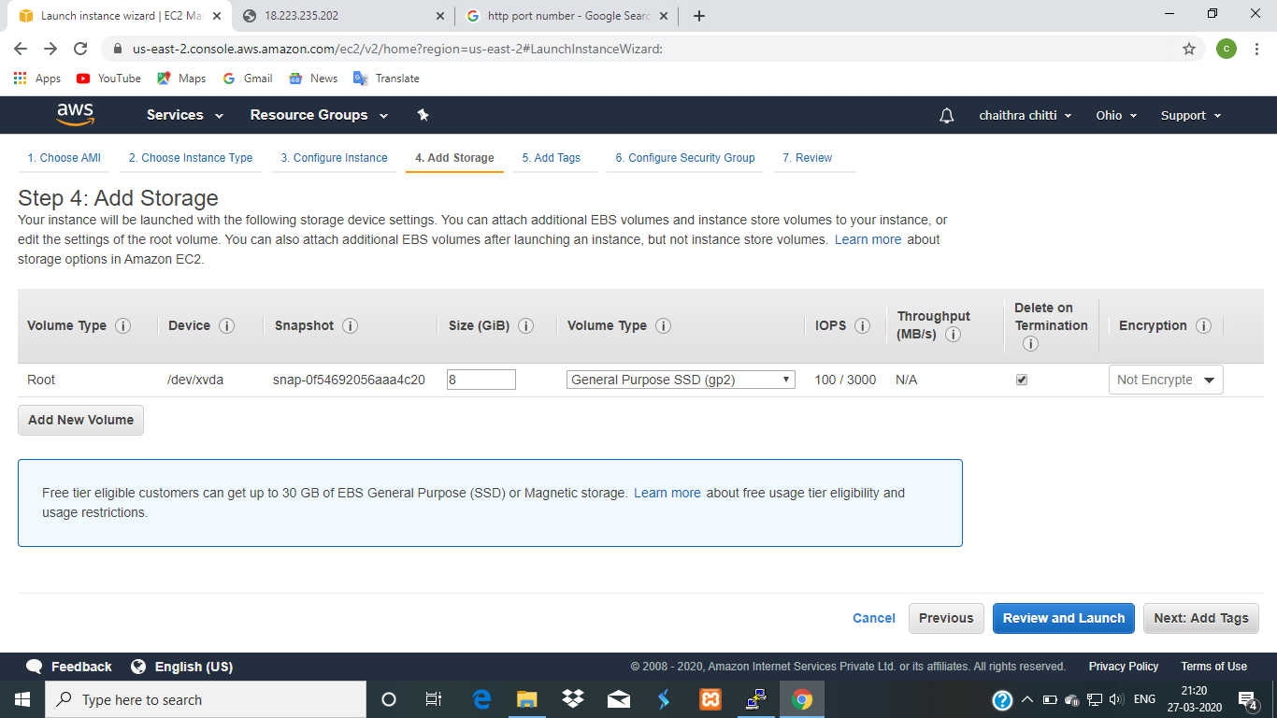

**Configuring security group**

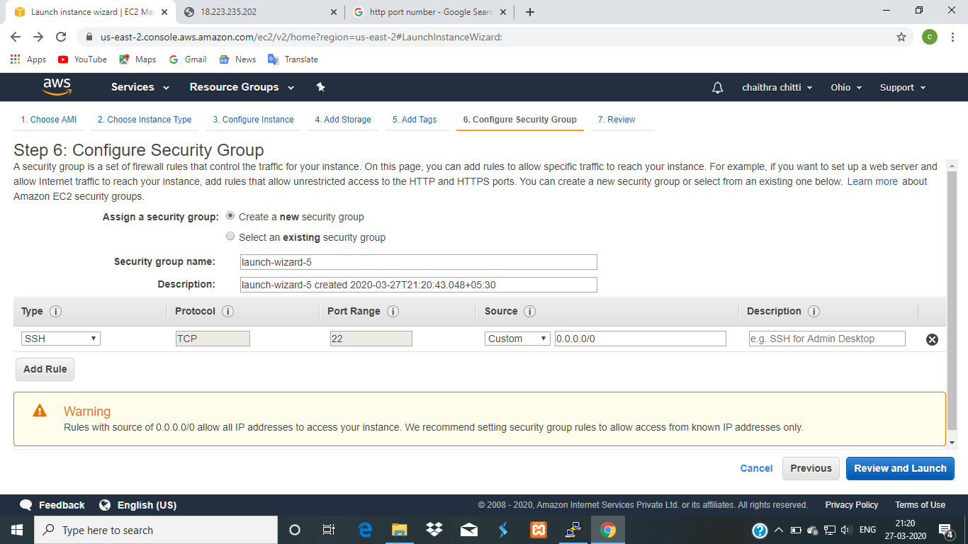

**Key pair download**

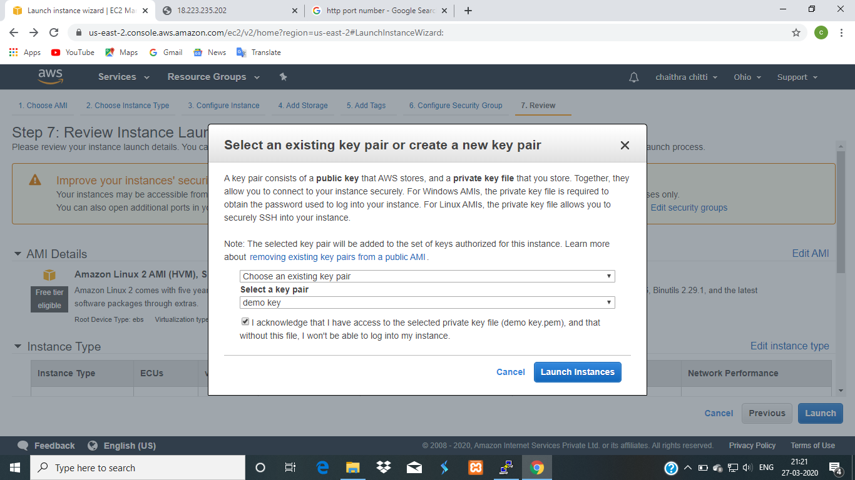

**PuTTygen conversion from pem to ppk**

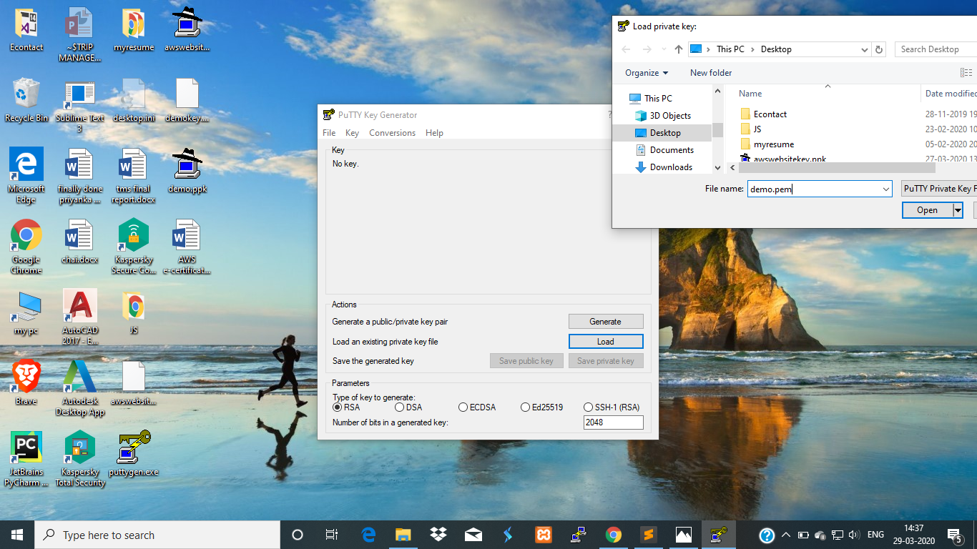

**Logged in EC2 black screen**

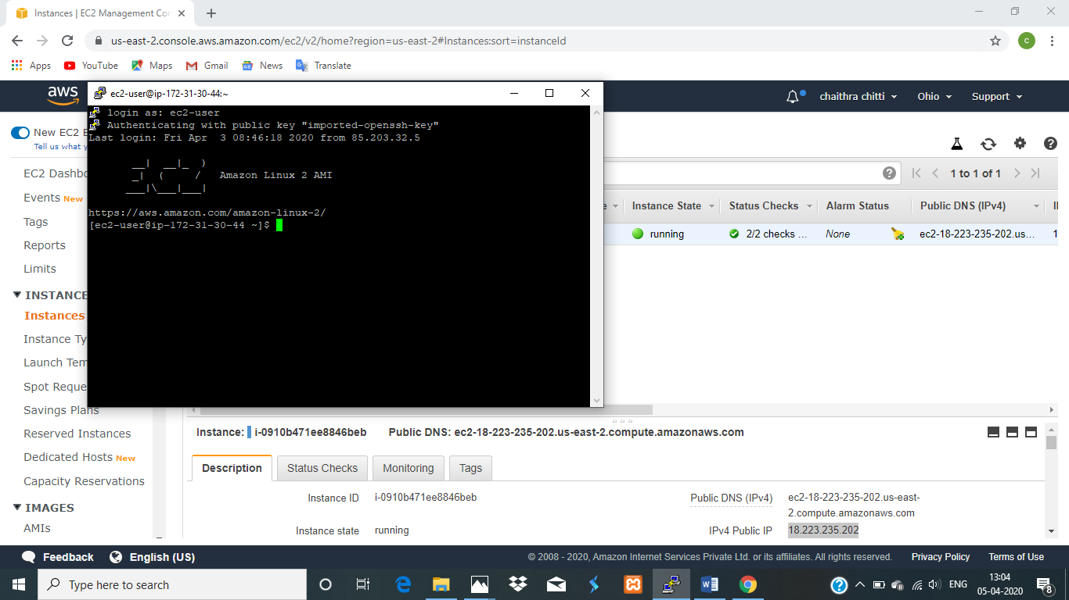

**Screenshot needed for s3**

**Creating a bucket**

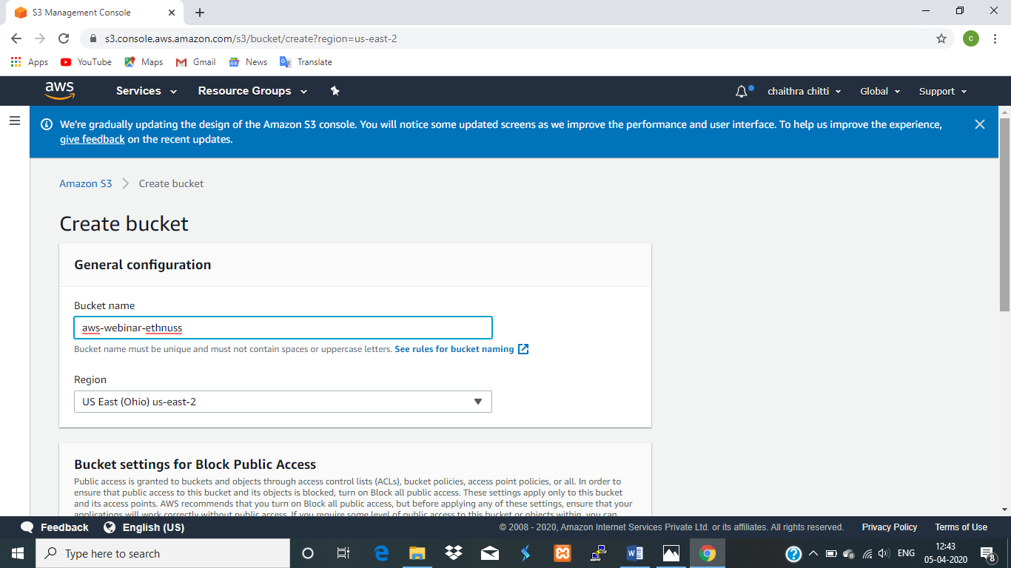

**Upload an object**

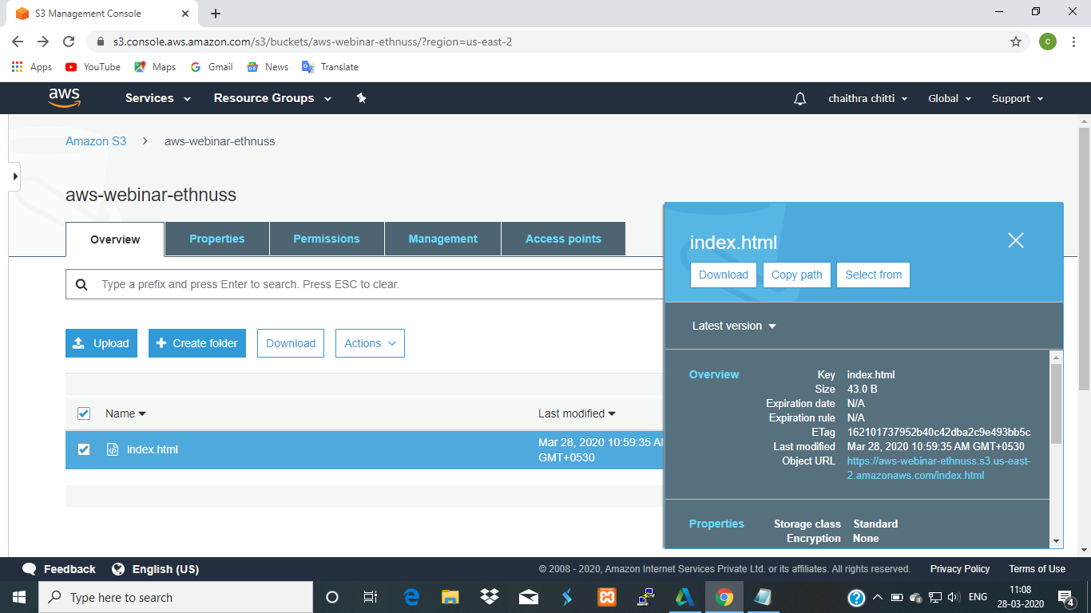

**Enabling static website**

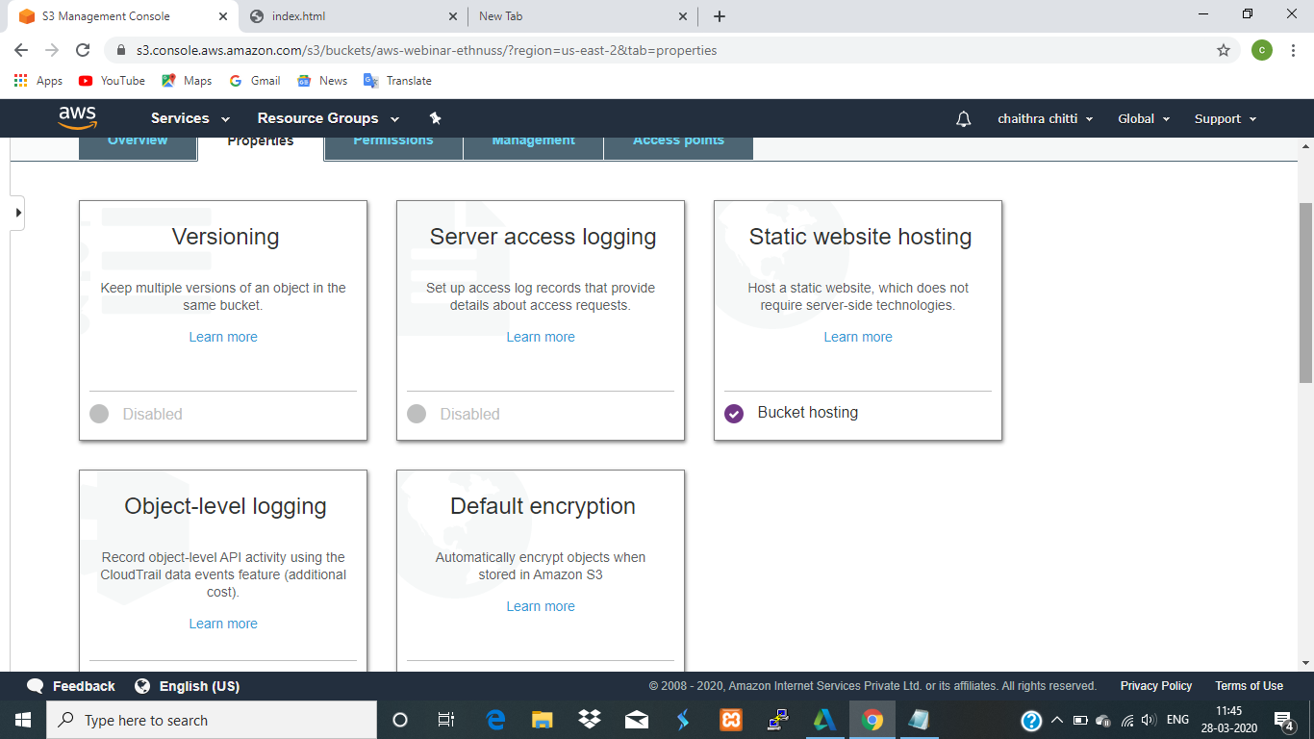

**Making the object public**

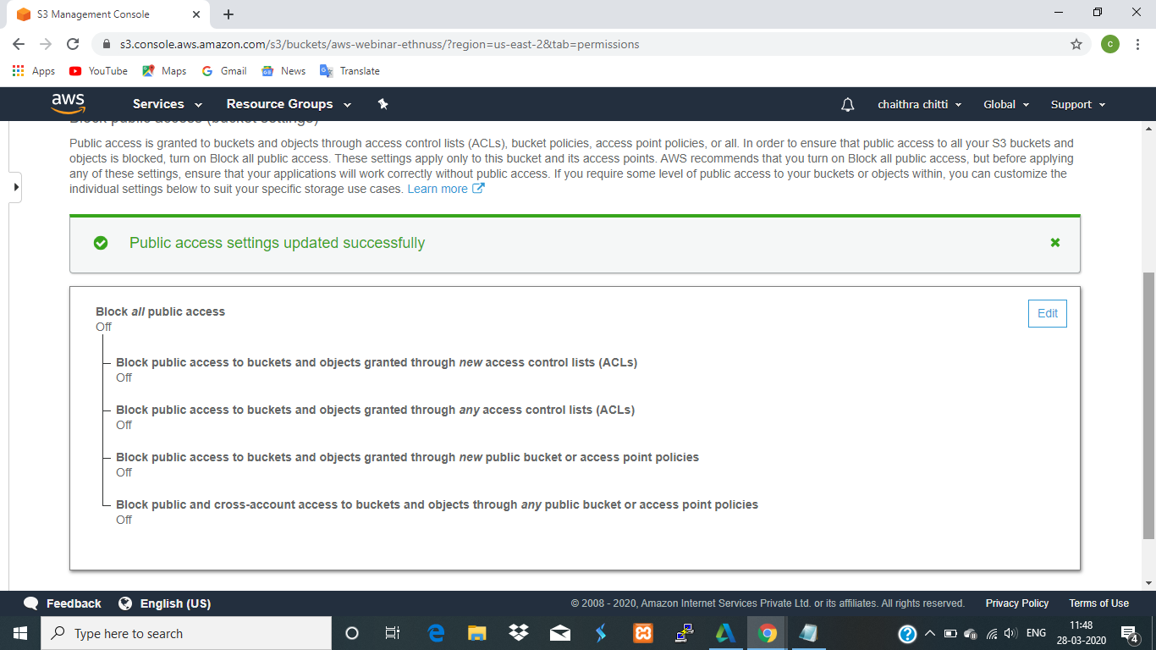

**Checking the s3 link on the server**

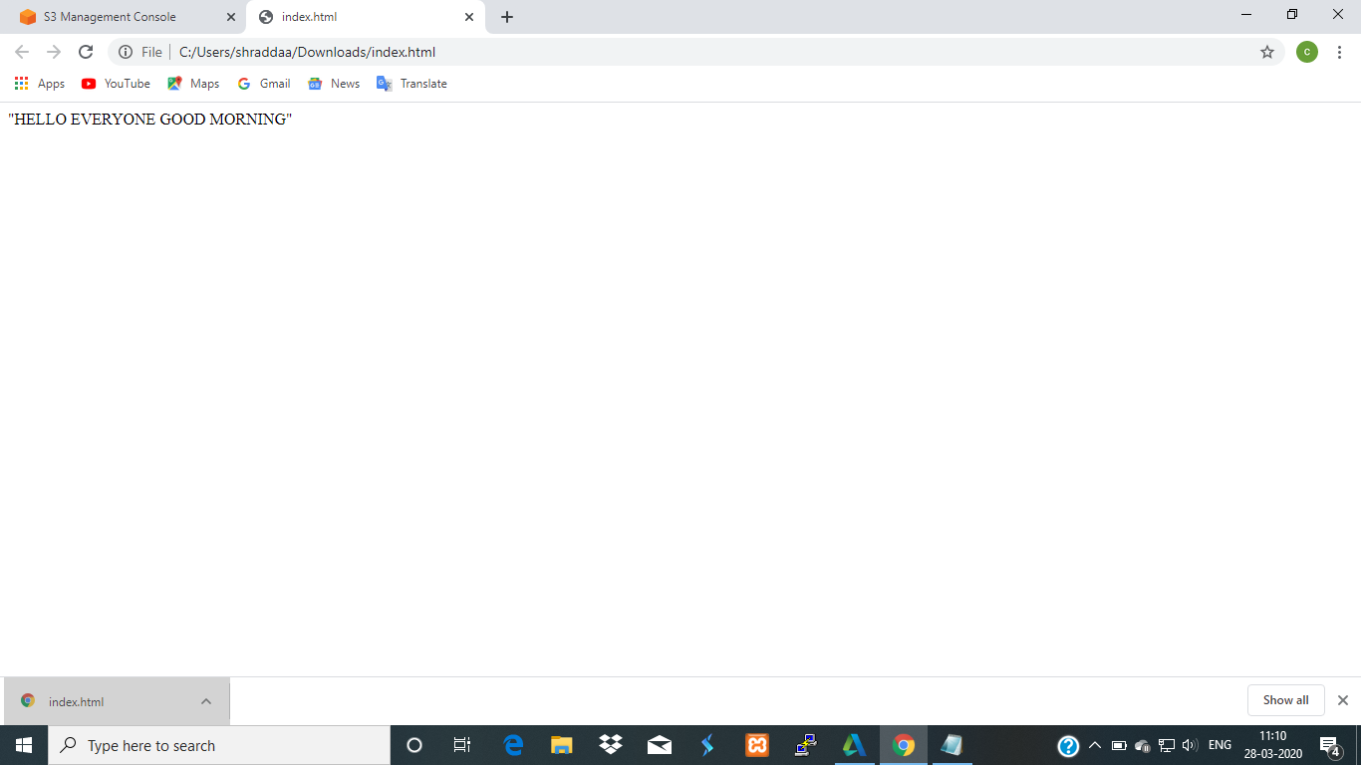

**Screenshot needed for recognition**

**Face detect**

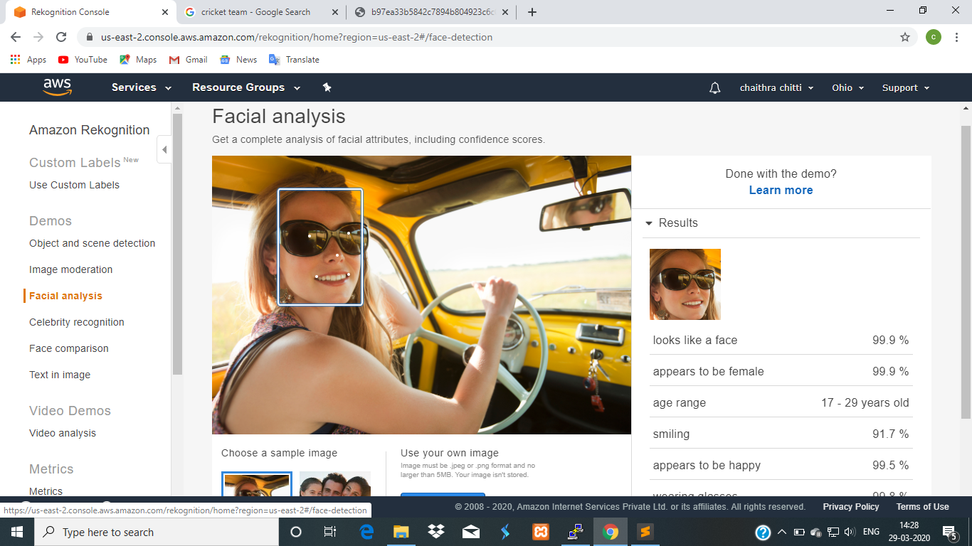

**Face compare**

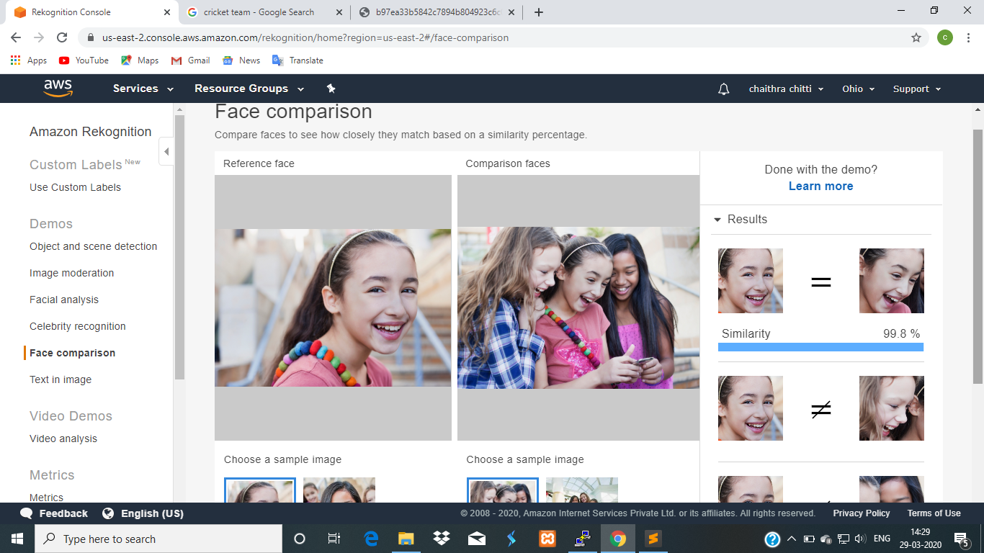

**Celebrity recognition**

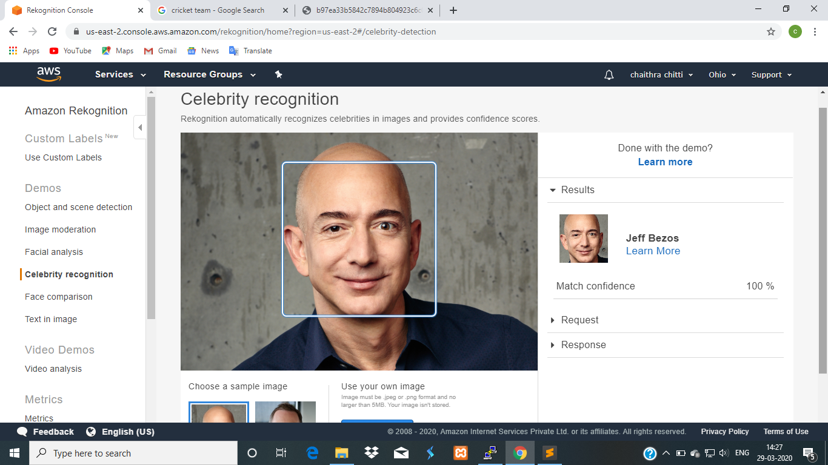

**Text in image**

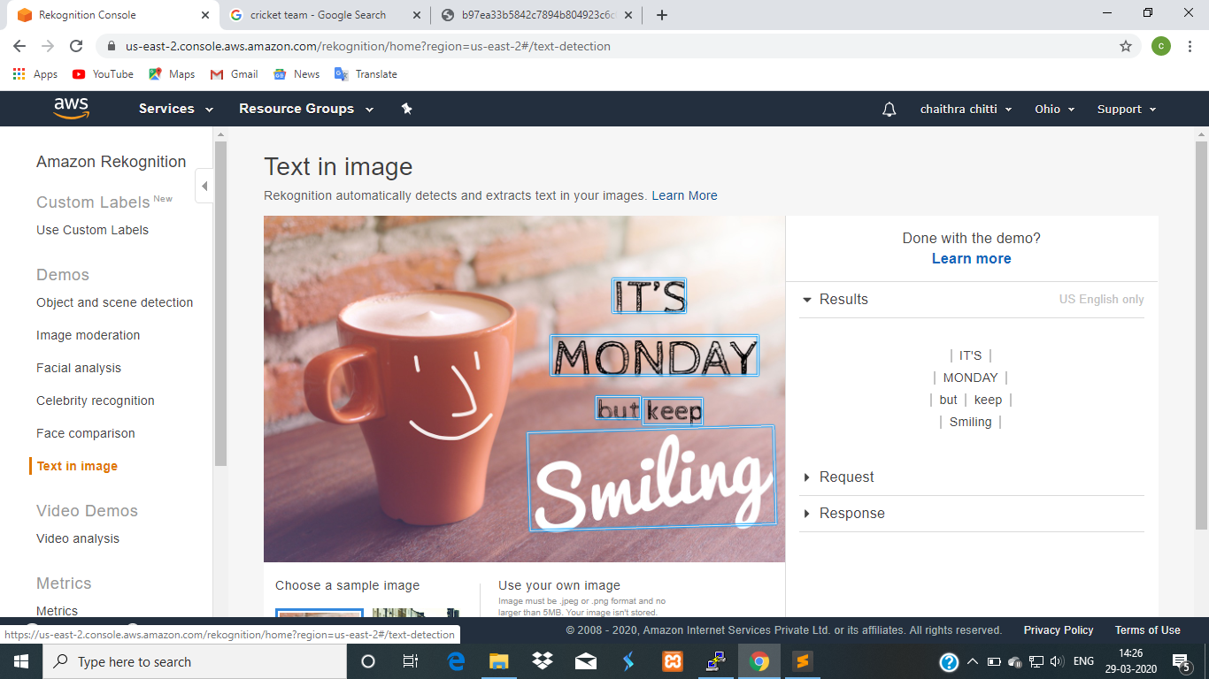

**Screenshots needed for EC2 and S3**

**Installing aws-sdk**

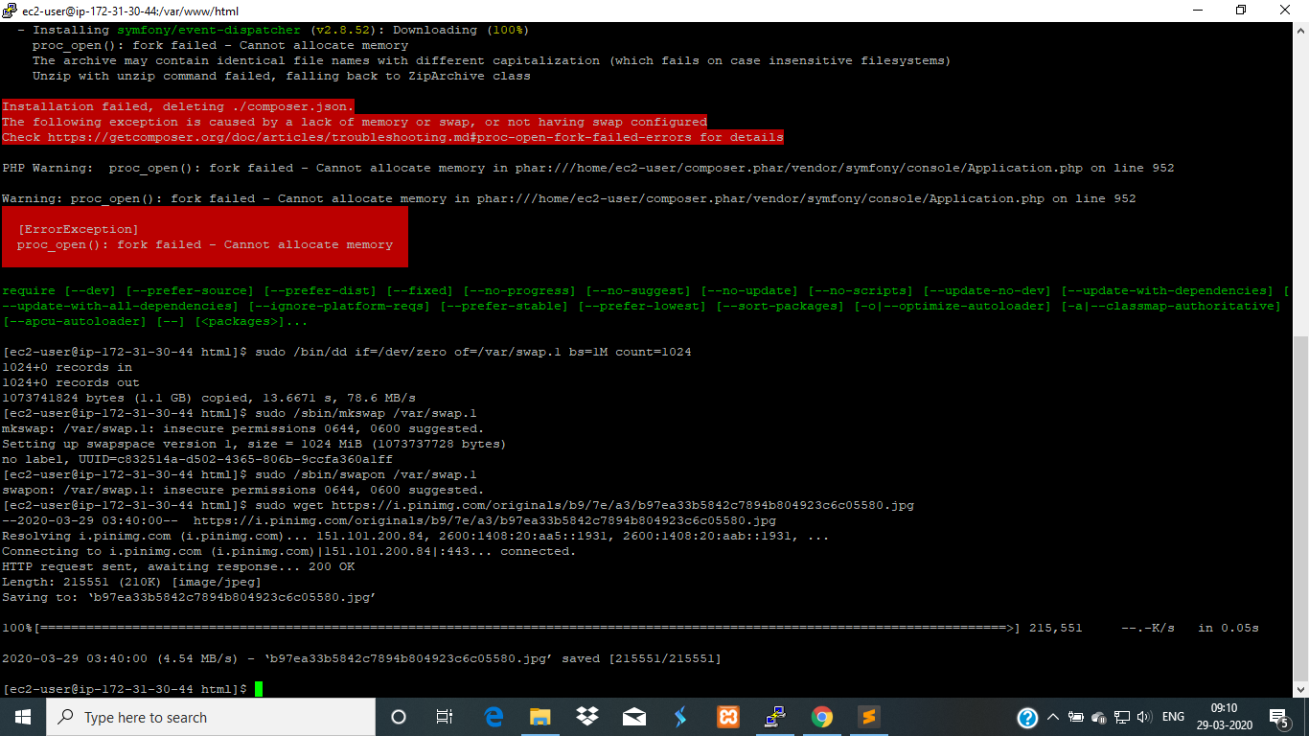

**Installing php**

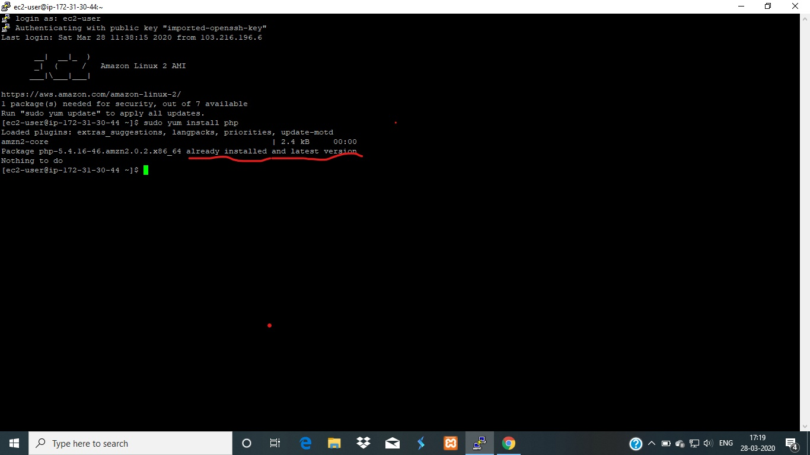

**Index.php file code**

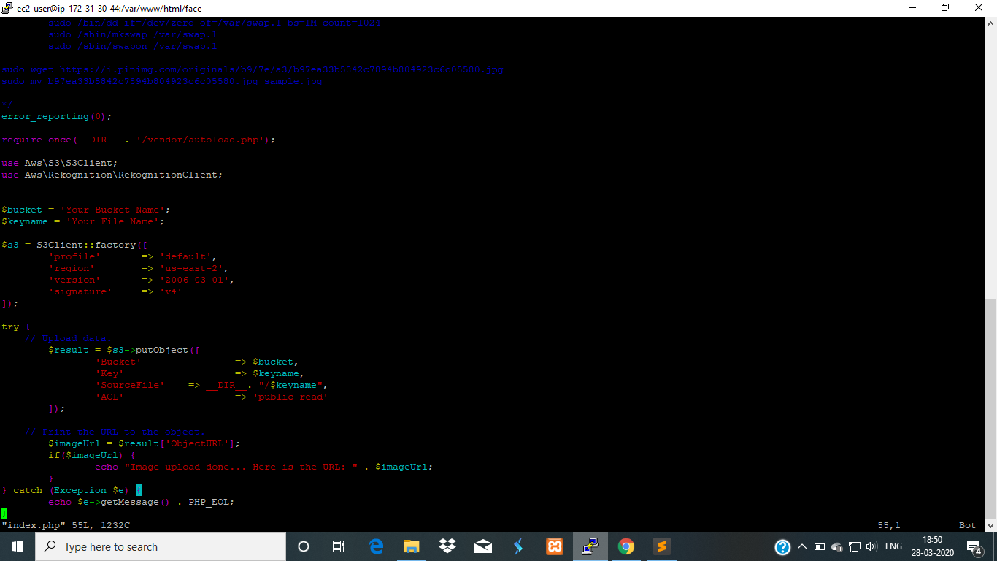

**Upload success screenshot**

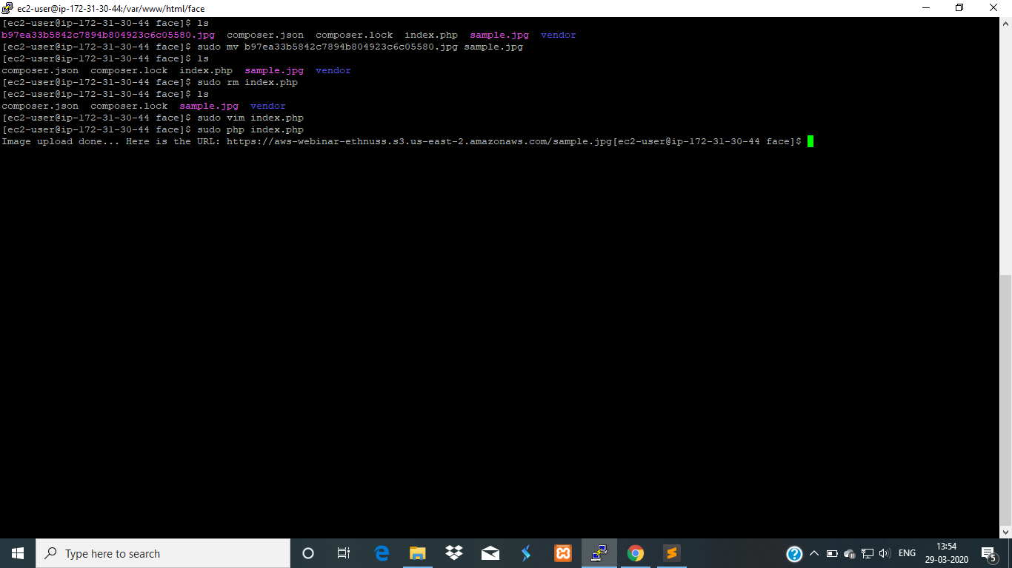

**Screenshot needed for the EC2 and Rekognition**

**Face detection success**

